USER MANUAL FOR WEB APPLICATION
Step 1: Open web application
Open the web application on your browser-
https://<Server_IP>
Eg: https://localhost

Step 2: Login
Login to UI using Admin/End-users' credentials
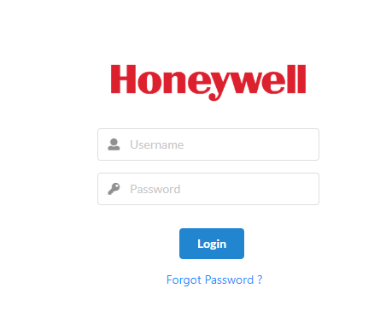
If Password is incorrect it shows Invalid credentials.
If the user forgets the password, there is an option to set new password by clicking on Forgot Password.
User will be prompted to enter username, Security question and the secret answer.
Once valid secret key is entered, user will be able to set new password.

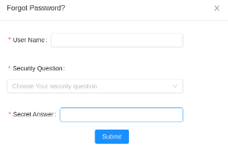

Step 3: Landing Page
The landing Page displays Parking Management System and Lighting Management System.
On click of Parking Management System and Wireless Lighting Management System, user will
be directed to PMS dashboard page and LMS dashboard page respectively.

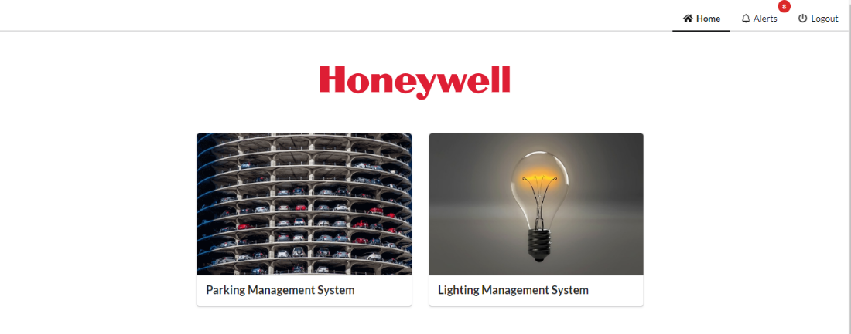
Wireless Lighting Management System
Dashboard:
- It shows floor details including THL values and a heatmap.
- This heatmap shows the presence of each THL device on the floor. By default, heatmap shows the temperature values captured by each device. User can select Humidity / Temperature / Lux options provided on top of the heatmap to view the corresponding values.
- If the user hovers over each device, he can find a popup with corresponding device name and Temperature / Humidity / Lux values captured by the same.

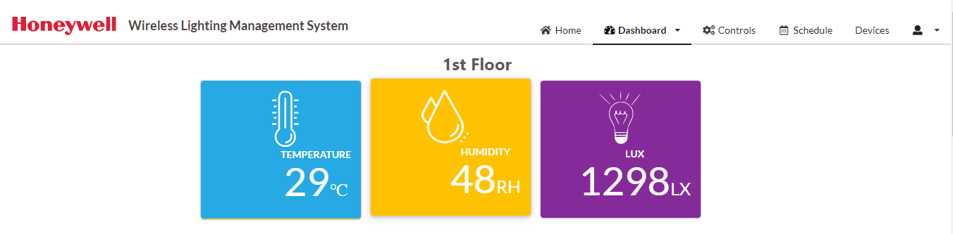

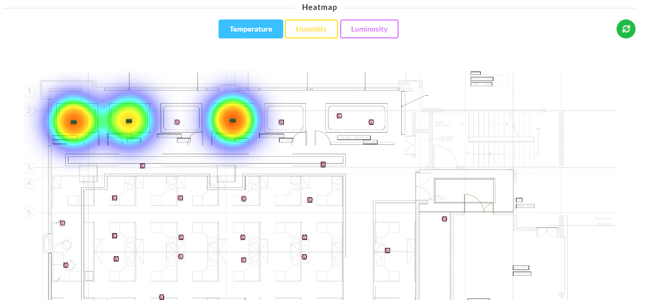

Controls:
- Admin will be able to control lights.
- This has zone-level light control as well as controlling individual lights.
- End-user doesn’t have access to this tab.
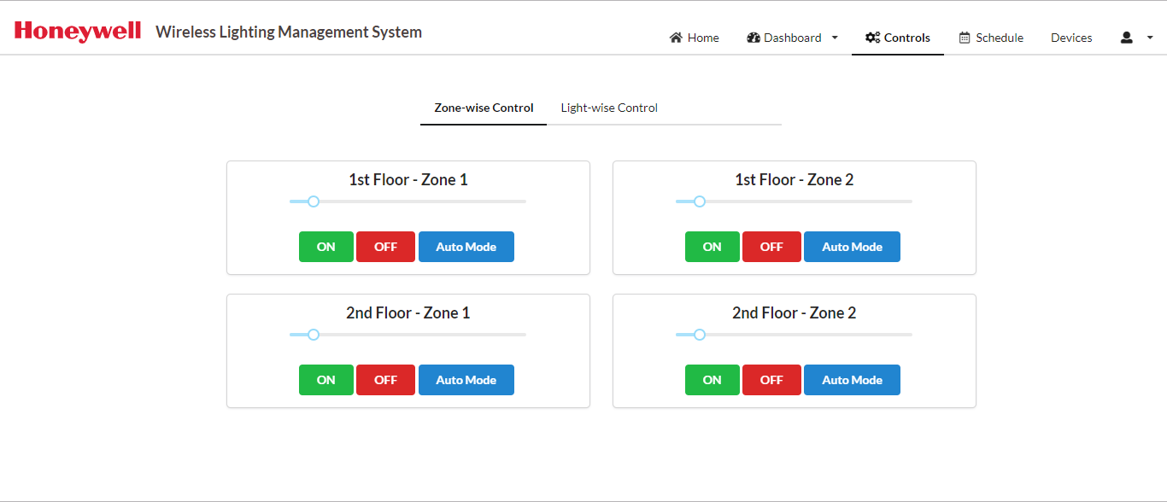
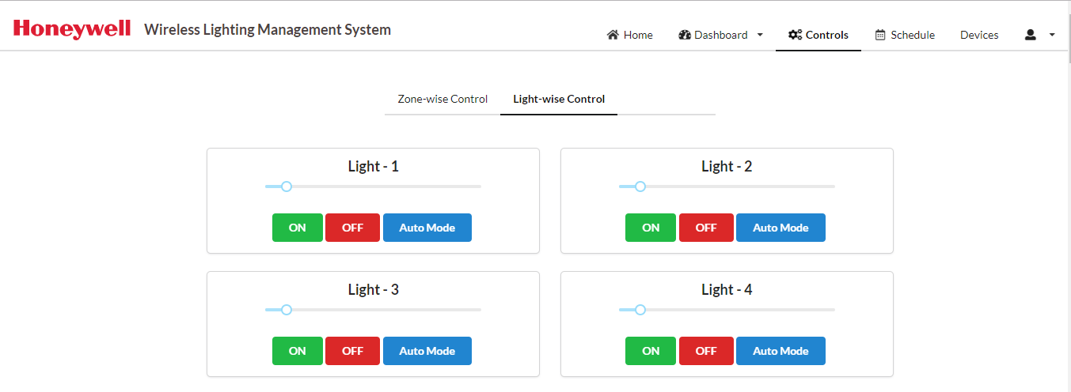
Schedule:
- Admin can schedule an event for switching ON/OFF the lights in a zone.
- He should create an event at least 30 minutes prior the current time.
- End-user doesn’t have access to this feature.
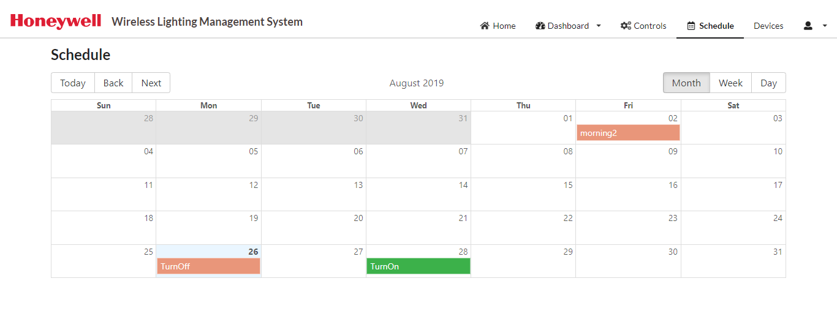

CREATING A SCHEDULE:
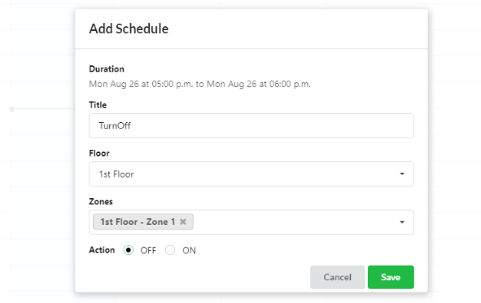

DELETING A SCHEDULE:
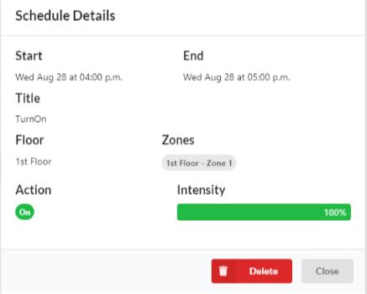

Alerts:
Admin can view the alerts for 3 different kinds of issues:
1) Device not communicating for the past 30 minutes.
2) Device hasn’t communicated at all since its registration.
3) Battery level is less than 30%.
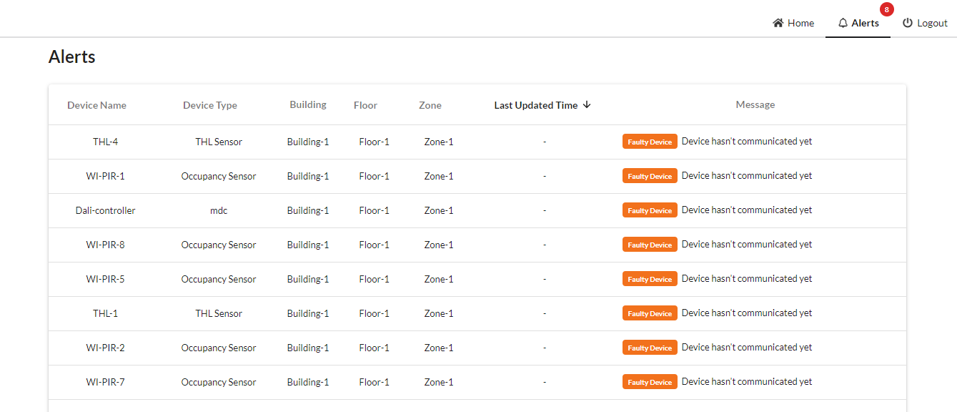

Device:
- It displays the list of all devices which shows Floor, Zone, Battery percentage, Network status, Device name, Device type.
- If the device hasn’t communicated for the past 45 minutes, the network status will be updated as OFF.
- We can also filter the device list based on zones.
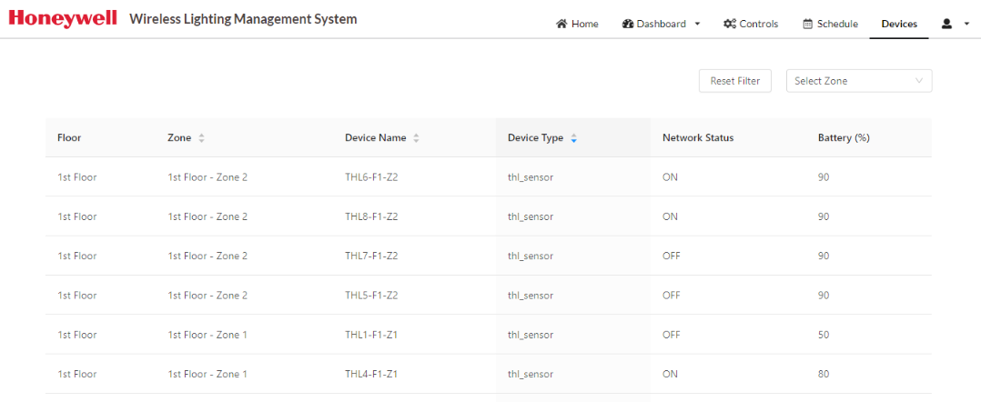

Settings:
When the user is logging in for the first time, he will be redirected to this page immediately after login.
Change Security Key
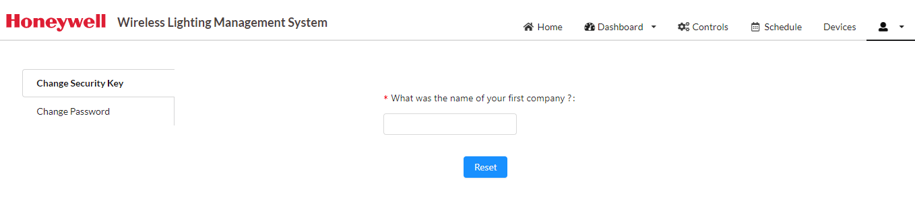
Change Password
User can reset the password at any point of time.
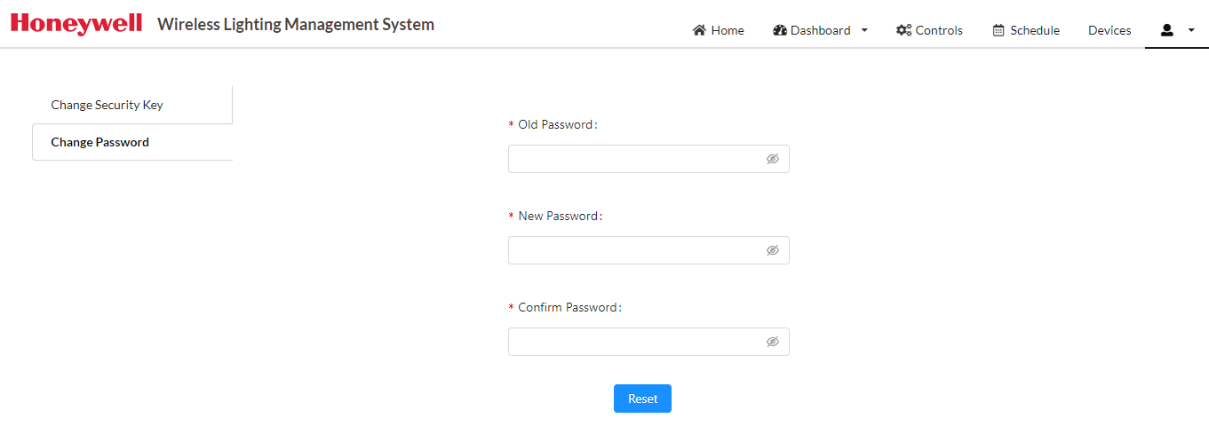

Parking Management System
Dashboard:
It shows all the floors in parking area.
Parking sensors detect the number of available spaces for parking and the occupied slots as well.
